Exno: 8

Date:

**INDEXING AND VIEW**

**AIM:**

To create a view table in the employee table and to insert more records to the table.

1. To create view table in employee table:

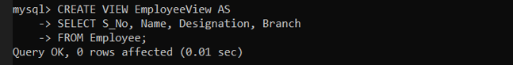

1. Insert more records to it:

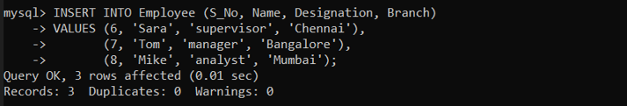

1. Select from employee’s:

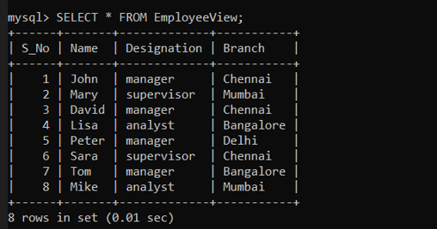

Result:

The view table is created and more records have been inserted.